Elastic pool:

* It is a cost-effective solution for managing and scaling a group or a pool of Azure SQL databases, with a utilization pattern characterized by low average utilization and infrequent spikes

All databases in an elastic pool:

* Belong to one Azure SQL server
* Share a set number of eDTUs
* Share a set amount of elastic pool storage
* Are priced for eDTUs and not individual databases like DTUs
* Can scale up to the given maximum amount of eDTUs
* Have a guaranteed minimum number of eDTUs

When to choose an elastic job?

Sizing an elastic job?

Configuring the elastic pool

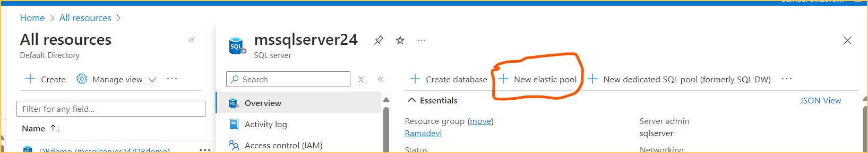

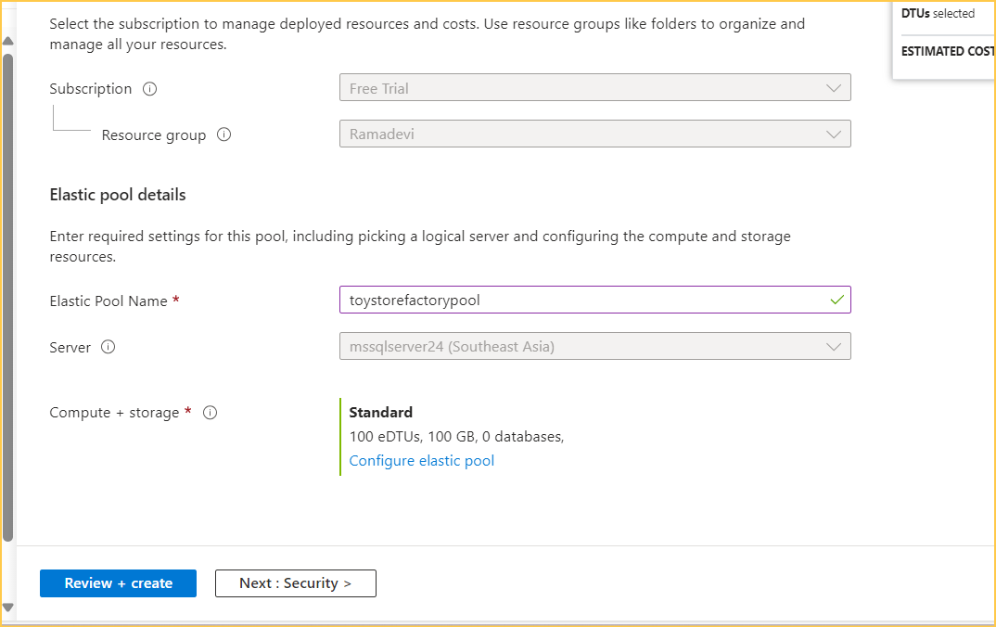

Adding the existence database to pool

* All resources------>toystorefactorypool---->overview page configure--->databases----->add databases

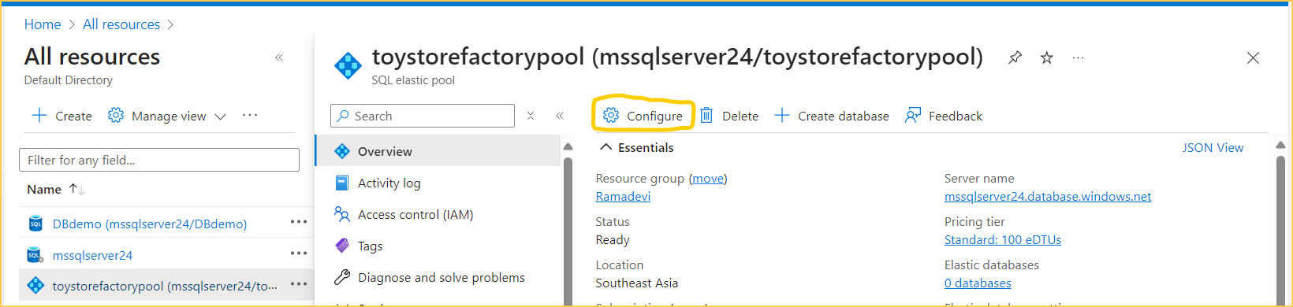

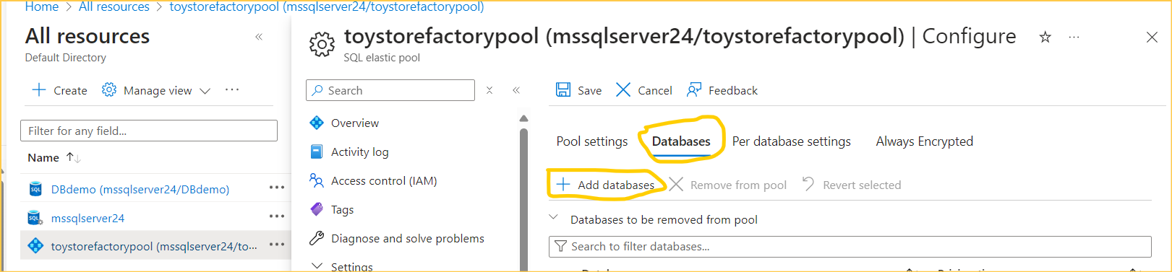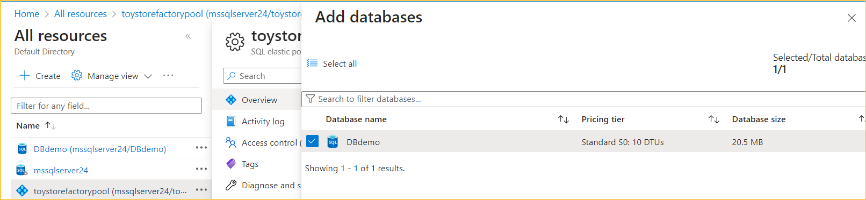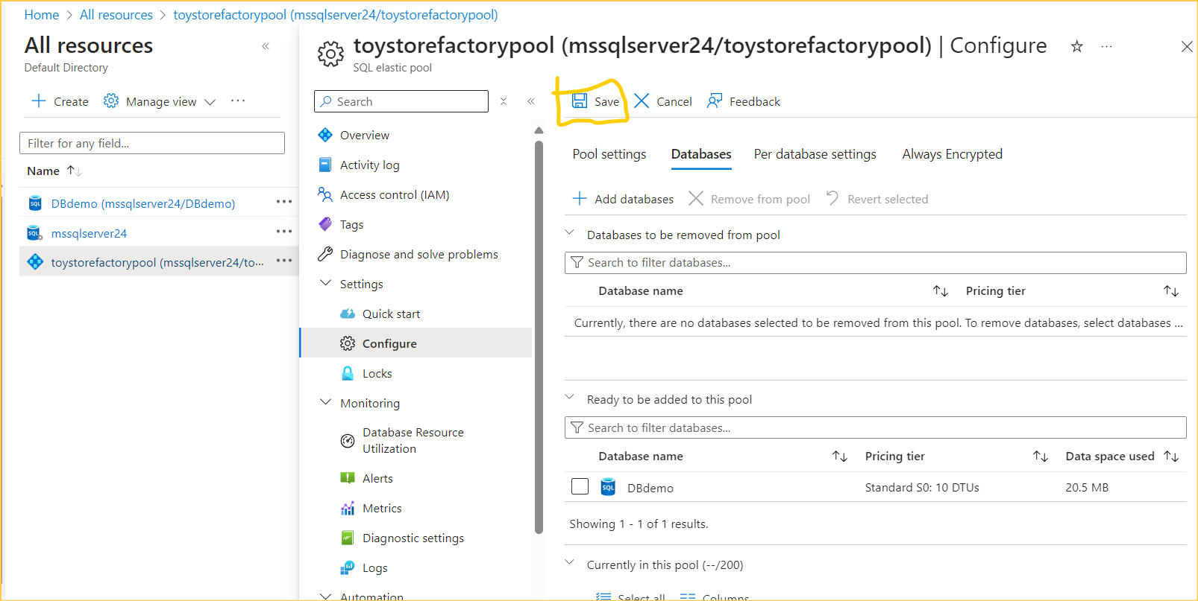

We can create a new database in the elastic pool

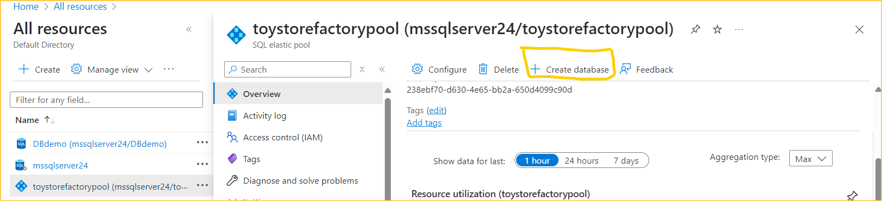

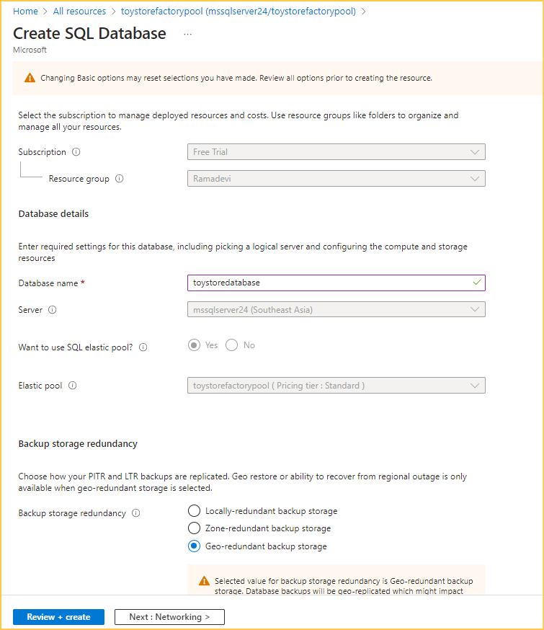

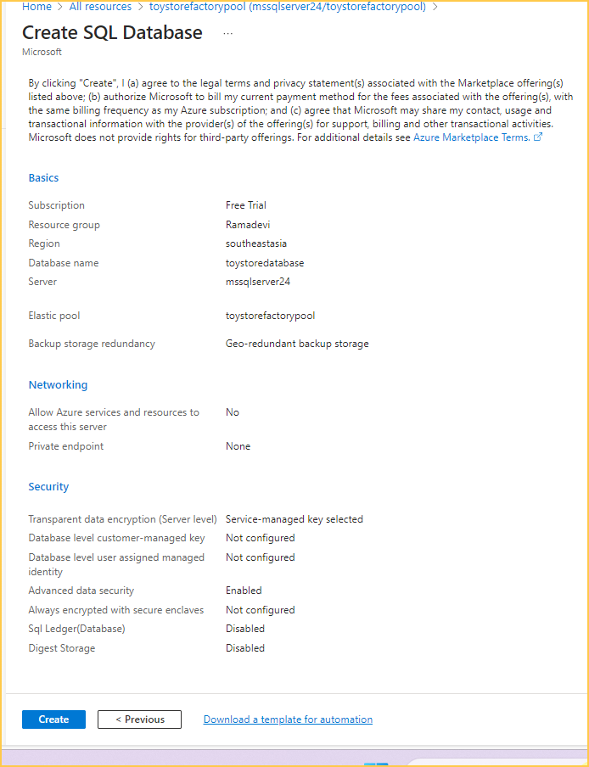

Here databases are added to the elastic pool, and we can see the resource utilization of databases in elastic pool

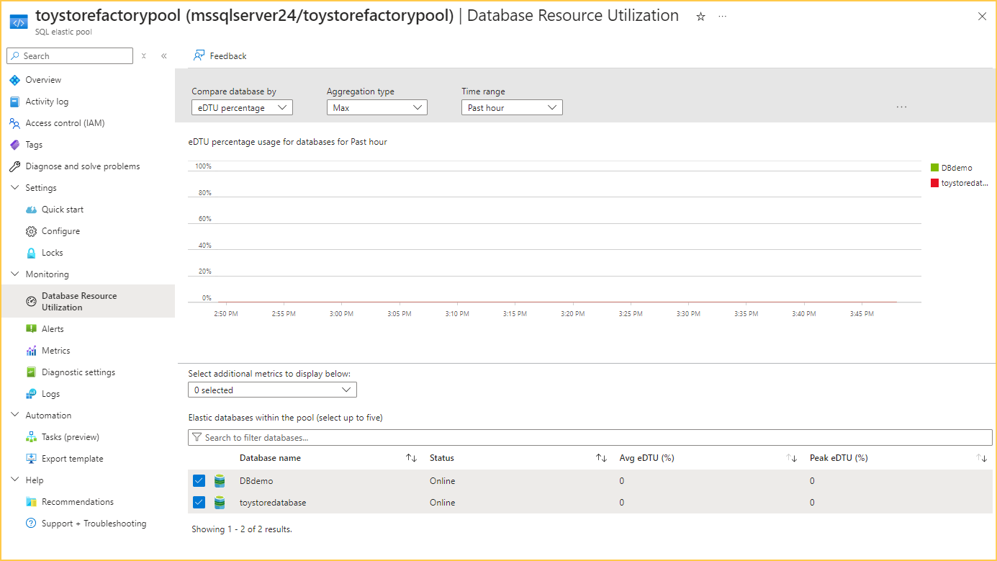

Elastic Database Jobs

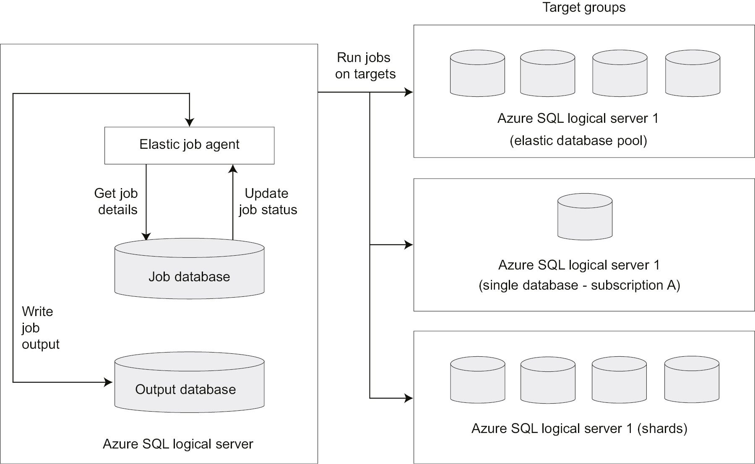

Elastic job Agent

An Elastic job agent is an Azure resource that's responsible for creating, executing, and managing jobs.

Job database:

**Creating the elastic job agent**

